# React

# ReactJS-HOL

# Mandatory HandsOn

Create a React Application named “ticketbookingapp” where the guest user can browse the page where the flight details are displayed whereas the logged in user only can book tickets.

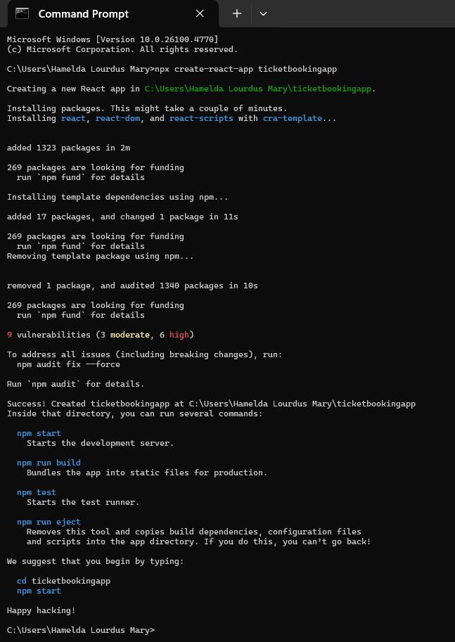

**App.js**

import { useState } from 'react';

import './App.css';

// Greeting Components

function UserGreeting() {

  return <h1>Welcome back</h1>;

}

function GuestGreeting() {

  return <h1>Please sign up.</h1>;

}

// Button Components

function LoginButton(props) {

  return (

    <button onClick={props.onClick}>

      Login

    </button>

  );

}

function LogoutButton(props) {

  return (

    <button onClick={props.onClick}>

      Logout

    </button>

  );

}

// Greeting Selector Component

function Greeting(props) {

  const isLoggedIn = props.isLoggedIn;

  if (isLoggedIn) {

    return <UserGreeting />;

  }

  return <GuestGreeting />;

}

// Main App Component

function App() {

  const [isLoggedIn, setIsLoggedIn] = useState(false);

  const handleLoginClick = () => {

    setIsLoggedIn(true);

  };

  const handleLogoutClick = () => {

    setIsLoggedIn(false);

  };

  let button;

  if (isLoggedIn) {

    button = <LogoutButton onClick={handleLogoutClick} />;

  } else {

    button = <LoginButton onClick={handleLoginClick} />;

  }

  return (

    <div  className="App-container">

      <Greeting isLoggedIn={isLoggedIn} />

      {button}

    <div className="content-margin">

      {isLoggedIn ? <UserPage /> : <GuestPage />}

      </div>

    </div>

  );

}

// Guest Page Component

function GuestPage() {

  return <p>Browse flights and view details. Please login to book tickets.</p>;

}

// User Page Component

function UserPage() {

  return <p>You can now book your tickets!</p>;

}

export default App;

**App.css**

.App-container {

  margin-left: 150px;  /* Shifts everything right */

  margin-top: 50px;    /* Adds top margin */

}

.content-margin {

  margin-top: 10px;

}

button {

  margin-top: 10px;

  padding: 5px 10px;

  font-size: 14px;

  cursor: pointer;

}

**Output:**

npm start

